Template for Evidence(s)
UI GreenMetric Questionnaire

University : ...
Country : ...
Web Address : …

[6] Education and Research (ED)
SAMPLE
[6.1] Number of Courses/Subjects Related to Sustainability Offered

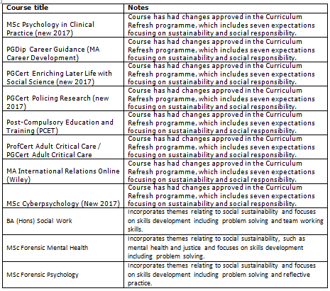 | 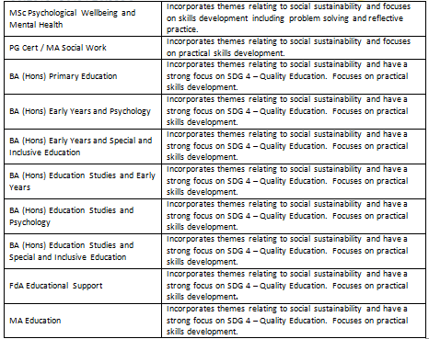
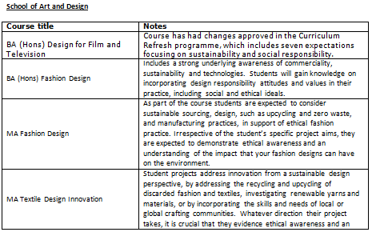 | 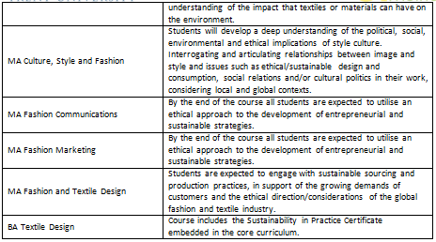
Example of Courses/Subjects Related to Sustainability (Nottingham Trent University, UK)

Description:
(Please describe sustainability courses/subjects offered on your campus. The following is an example of the description. You can describe more related items if needed.)

Above is a list of the courses that have had changes approved through NTU’s Curriculum Refresh programme which aims to embed sustainability into all course and module content offered by the University.
The list also includes courses with sustainability already embedded, and those that include the Sustainability in Practice Certificate as part of the core curriculum.
Total number of courses with sustainability embedded for courses running: 185

Additional evidence link (i.e., for videos, more images, or other files that are not included in this file):

